**Asiqul Hoque**

**Section 4 Group Functions**

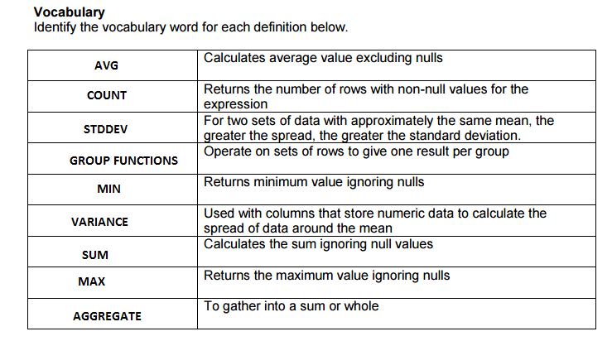

**1.**

**AVG**

Returns the average of a set of values

SELECT AVG(salary)

FROM employees;

**SUM**

Returns the sum of a set of values

SELECT SUM(salary)

FROM employees;

**MIN and MAX**

Return the minimum and maximum value from a set of values

SELECT MIN(department_id)

FROM departments;

SELECT MAX(last_name)

FROM employees;

**COUNT**

Returns the number of rows counted with non null values for the expression specified

SELECT COUNT(commission_pct)

FROM employees;

**STDDEV**

A statistical function that returns the standard deviation ignoring null values for expressions of NUMBER type

SELECT STDDEV(salary)

FROM employees;

**VARIANCE**

A statistical function that returns the variance ignoring null values for expressions NUMBER type

SELECT VARIANCE(salary)

FROM employees;

**2.Select round(avg(cost),2)**

**from d_events;**



**3.Select avg(salary)**

**from f_staffs**

**where manager_id=19;**



**4.Select sum(salary)**

**from f_staffs**

**where id in(9, 12);**



**5.Select min(salary), max(hire_date), max(last_name), min(last_name)**

**from employees**

**where department_id in(50, 60);**



**6. 1 ROW**

**7.More people were paid by salary**

**8. March 30, 1969**

**9. Select avg(order_number)**

**from f_orders**

**where order_date between '01-Jan-02' and'31-Dec-02';**



**10.select max(hire_date)**

**from employees;**



**11. SUM(operating_cost)**

**12.Which clauses represent valid statements?**

**____VALID___a. FROM event_date**

**__VALID_____b. SELECT SUM(cost)**

**___VALID____c. SELECT SUM(event_date)**

**_VALID______d. SELECT description, AVG(cost) AS "Expense"**

**___INVALID____e. WHERE MIN(id) = 100**

**___VALID____f. SELECT MAX(AVG(cost)**

**__VALID_____g. SELECT MIN(event_date)**